MongoDB on Heroku

<https://elements.heroku.com/addons/mongolab>

Click on “Install mlab MongoDB”.

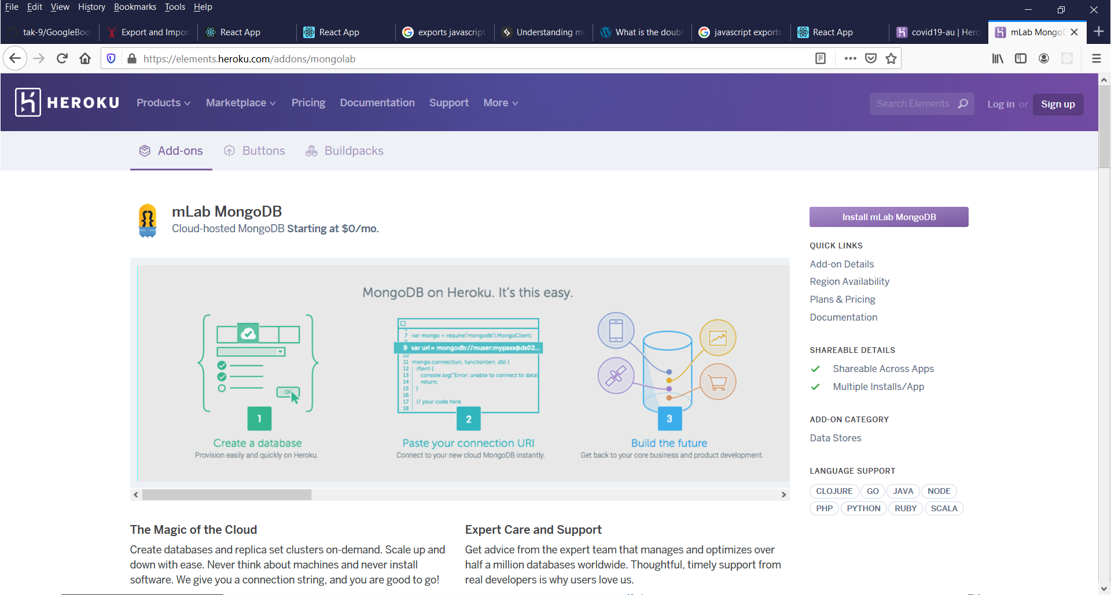

Find app and click on “Provision add-on”.

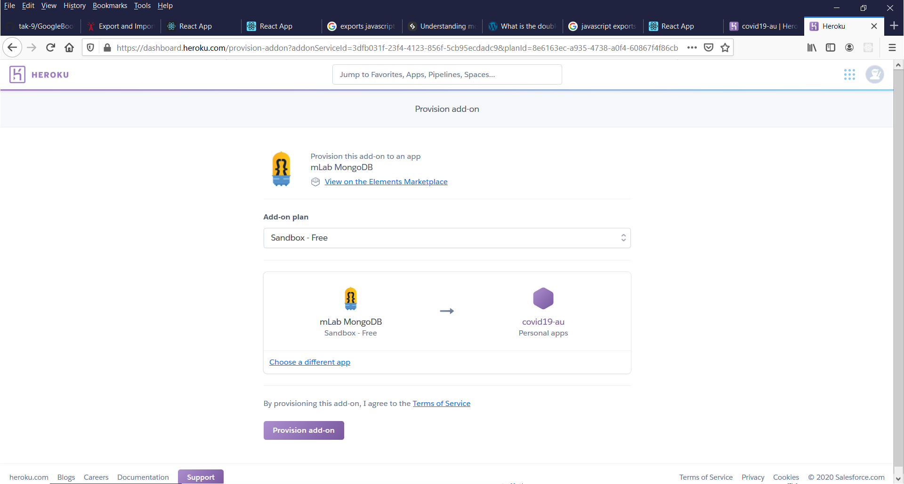

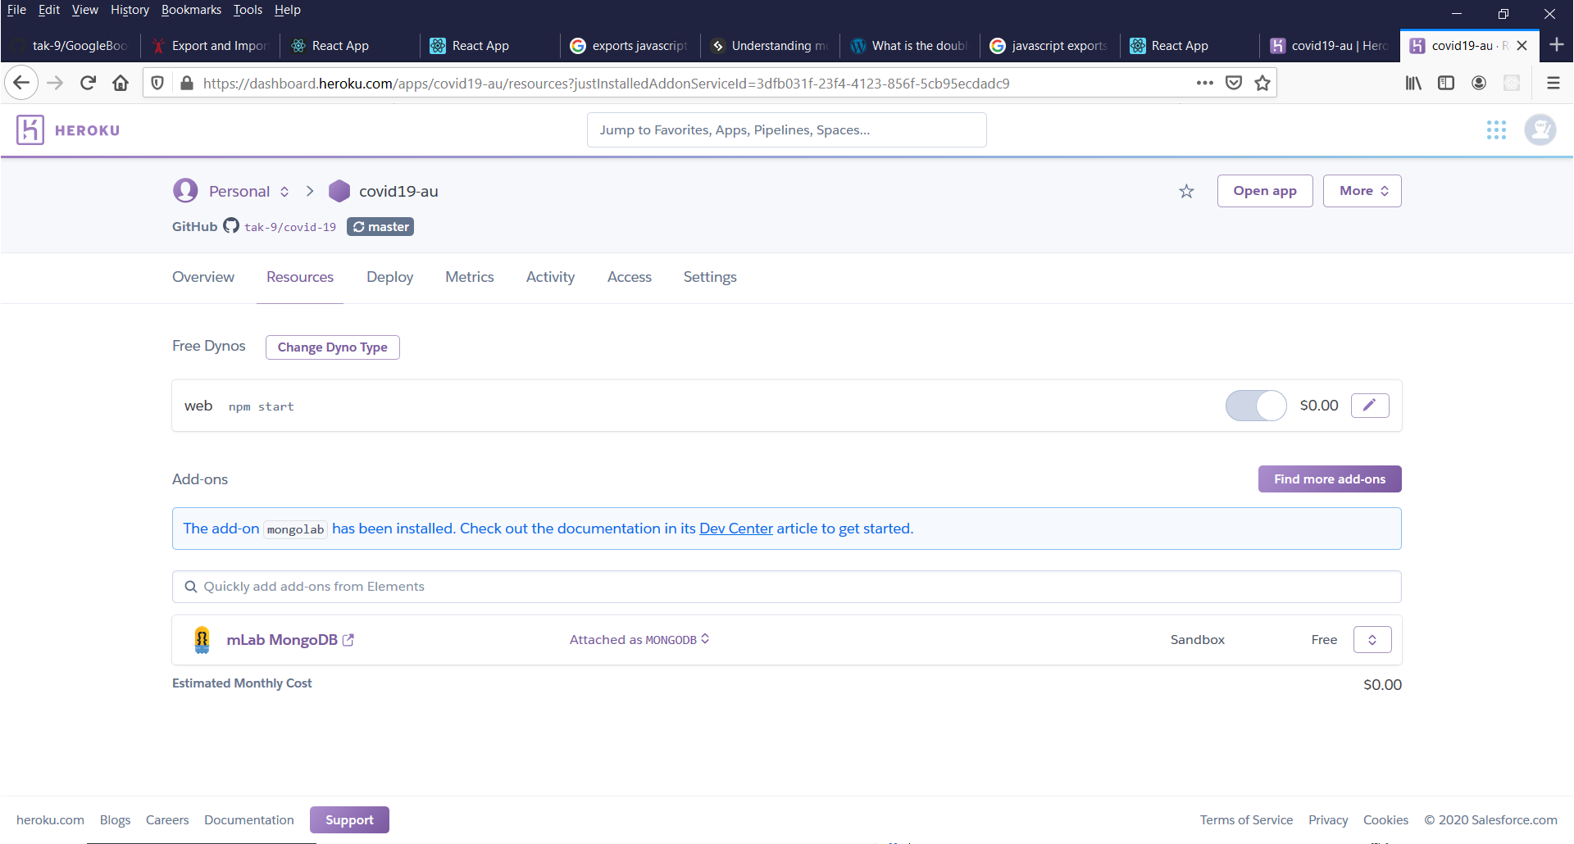

Go to Settings > Config Vars. Click on “Reveal Config Vars” button.

Find database properties.

mongodb://<dbuser>:<dbpassword>@<hostname>:<portnumber>/<dbname>

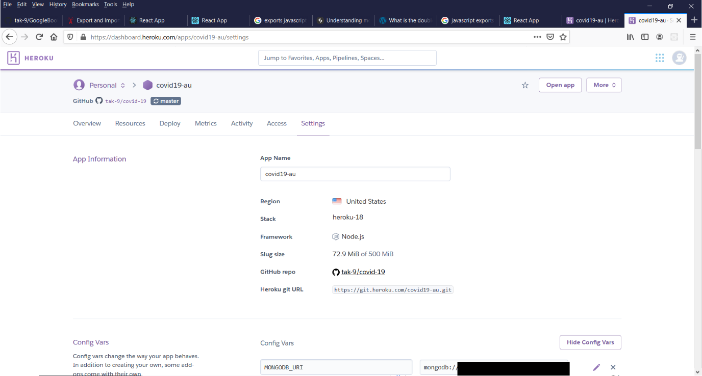

# Robo 3T

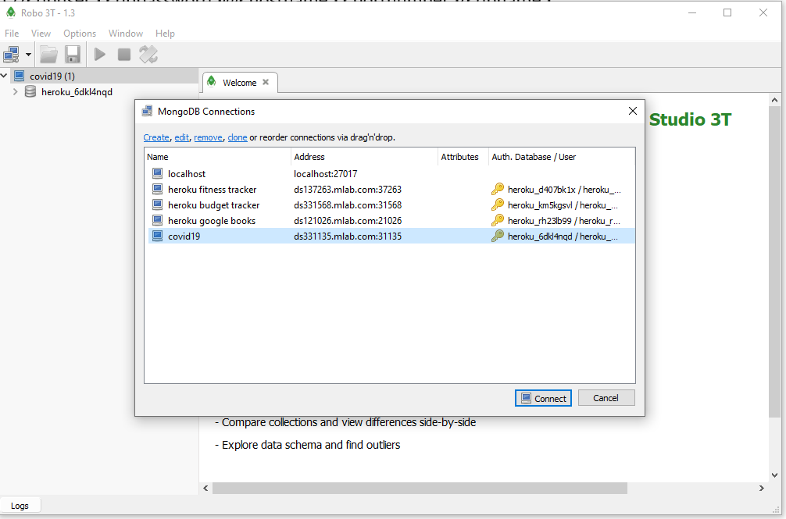

Click on server icon  on toolbar.

Click on Create in the dialog box.

Enter the properties.

Name, Address and Port number.

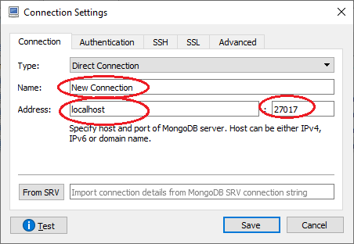

Check “Perform authentication”.

Enter the properties.

Database, User Name and Password.

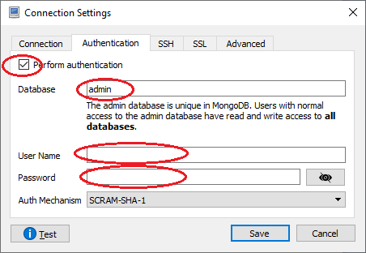

Then, click “Save”.

Open the “MongoDB Connections” again. Select the new database and click “Connect”.

